**Console Output:**

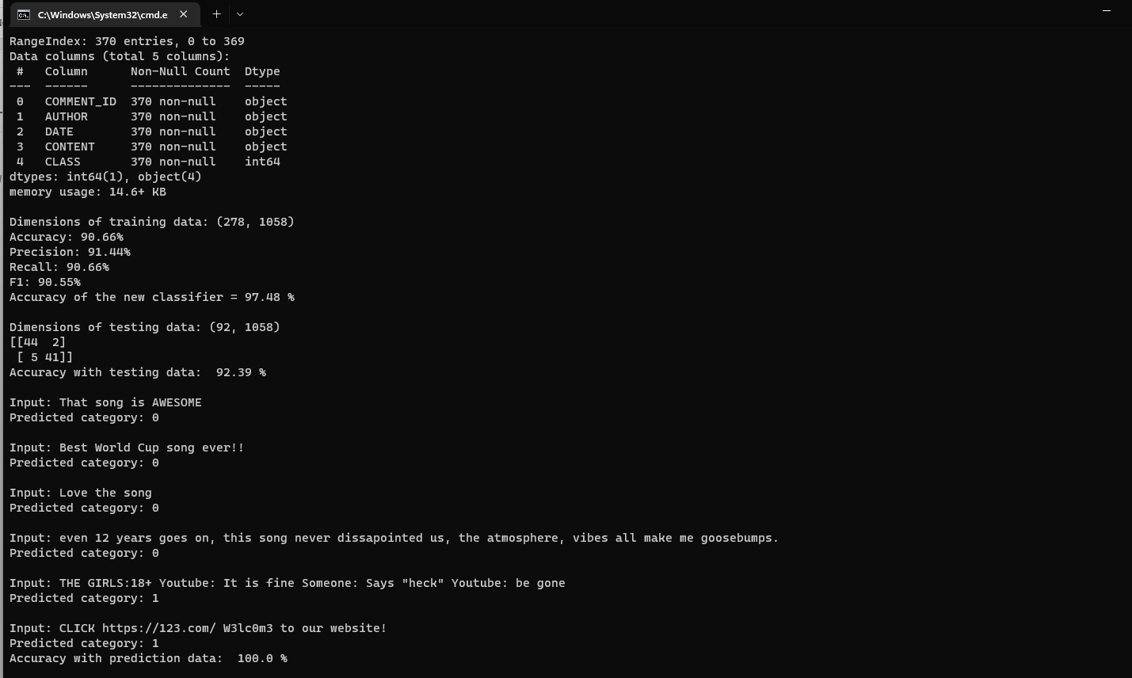

**Our findings:**

We first checked the data info and then saw if any columns can be dropped for better results. Author, Comment_id and Date could be dropped since they were just extra noise and did not add any result to the output. We then checked for null values and did not have any. We also remove the stop words for better data accuracy. Then, we downscale the data using the TFI-DF Transformer which further improves the accuracy by managing the frequency of repeated words. The accuracy of the model was found out to be 100% including the 6 prediction comments we fed into the model.